**Robustness Diagrams:**

Post Question:

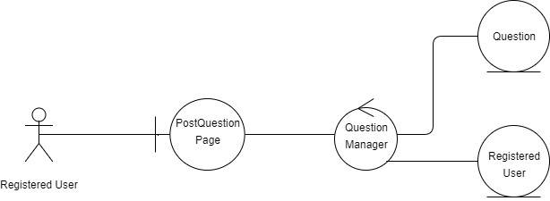

Post Solution:

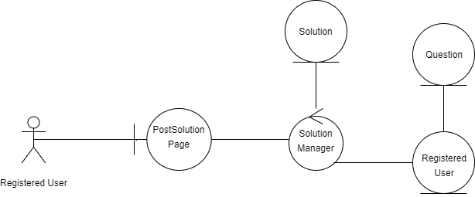

**Collaboration/Sequence Diagrams:**

Post Question:

1. Enter question information
2. Pass question information
3. Create question
4. Return question
5. Add the question to the user’s list of questions
6. Successfully added
7. Successfully added
8. Successfully added

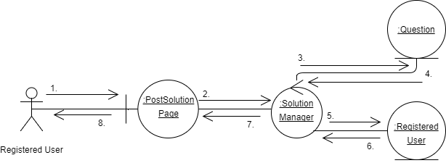

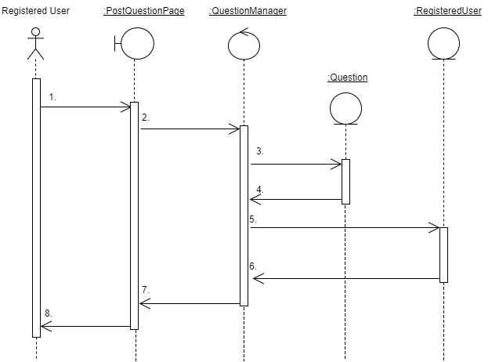

Post Solution:

1. Send Solution information
2. Pass solution information
3. Create solution
4. Return solution
5. Pass solution
6. Store solution in the question
7. Successfully added
8. Successfully added
9. Successfully added
10. Successfully added

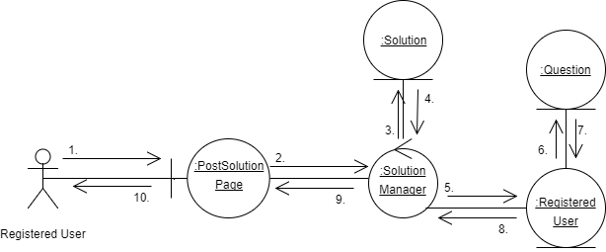

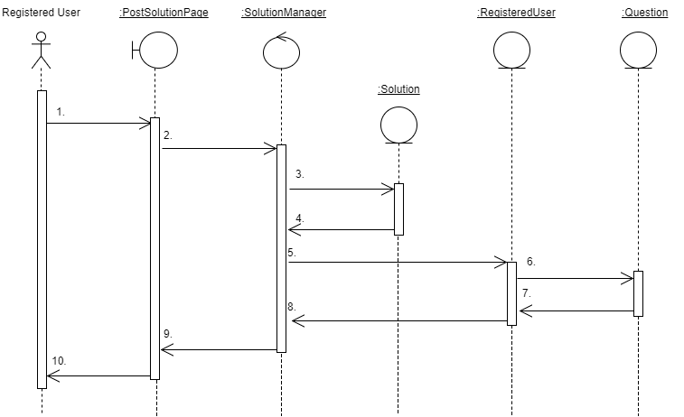

**Activity Diagram:**

